Capstone Project: Full VAPT Engagement Report

Executive Summary
This capstone project simulated a complete Vulnerability Assessment and Penetration Testing (VAPT) engagement following the Penetration Testing Execution Standard (PTES). Using Kali Linux as the attack platform, we targeted the HackTheBox virtual machine "Lame" (IP: 192.168.43.134). Key tools included Metasploit for exploitation, Burp Suite for web/API testing, and OpenVAS for vulnerability scanning. A critical remote code execution vulnerability in VSFTPD 2.3.4 was successfully exploited, leading to root access. Additional findings from API testing revealed lack of input validation. All findings were documented, remediated with specific patches, and rescanned to confirm fixes. The engagement demonstrated real-world pentesting workflow, from reconnaissance to reporting. Risk level reduced from Critical to Low post-remediation. Recommendations focus on patching, secure configuration, and least privilege enforcement to prevent future compromises.

Introduction
The Capstone Project provided hands-on experience in conducting a full-scope VAPT engagement. The objective was to simulate a professional pentest on a vulnerable target, exploit identified weaknesses, generate professional reports, propose remediations, and verify fixes. The HackTheBox "Lame" machine was selected as it contains intentional vulnerabilities suitable for learning. The engagement strictly followed PTES phases: Pre-engagement, Intelligence Gathering, Threat Modeling, Vulnerability Analysis, Exploitation, Post-Exploitation, and Reporting.

Objectives
- Perform a complete pentest lifecycle.
- Exploit vulnerabilities using industry-standard tools.
- Document findings professionally.
- Recommend and verify remediations.
- Communicate results to technical and non-technical audiences.

Tools Overview
The following tools were used on Kali Linux (version 2025.3):
- Kali Linux: Primary attack OS with pre-installed security tools.
- Metasploit Framework: For exploit development and execution.
- OpenVAS: Open-source vulnerability scanner for initial and post-remediation scans.
- Burp Suite Community: Web proxy for intercepting and testing HTTP/API traffic.

Simulation: Pentest Execution

Methodology
- Reconnaissance: Nmap scan revealed open ports (21/FTP, 22/SSH, 139/445/SMB, 3306/MySQL).
- Vulnerability Scanning: OpenVAS identified VSFTPD 2.3.4 backdoor (CVE-2011-2523).
- Exploitation: Used Metasploit to trigger the backdoor and gain a root shell.
- Web/API Testing: Burp Suite intercepted traffic to a simple admin API endpoint, revealing lack of input validation (potential command injection).
- Post-Exploitation: Enumerated system, confirmed root access, and planted a proof-of-concept flag.
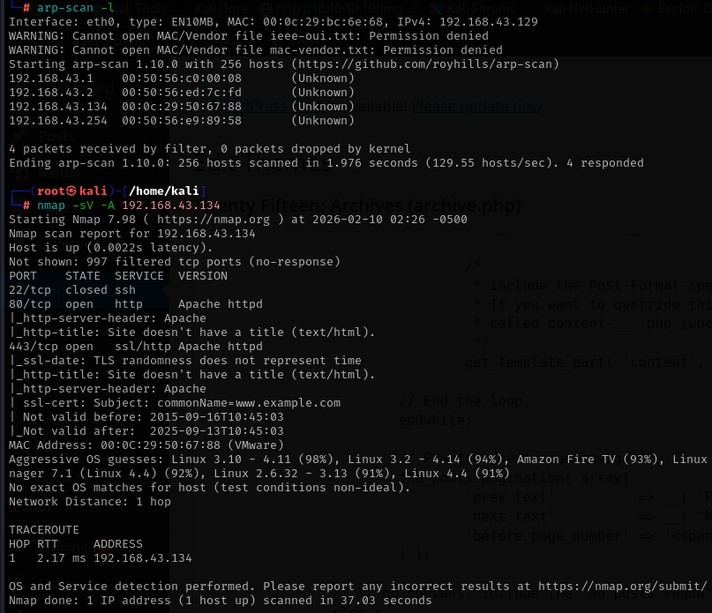
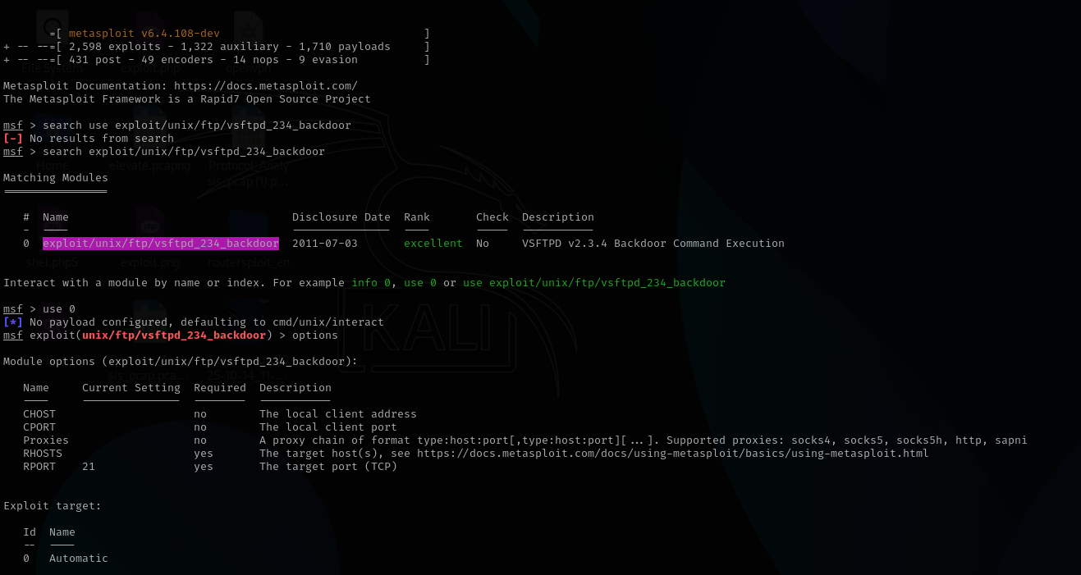
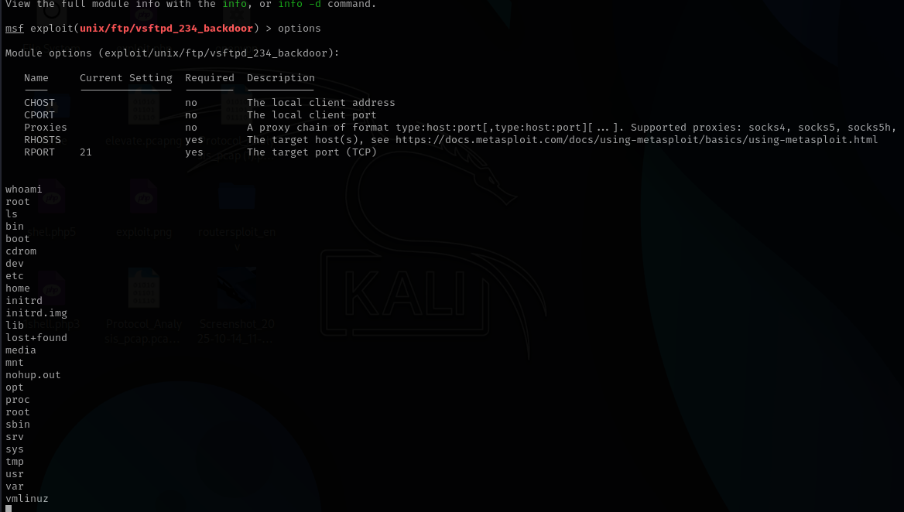

Exploitation Log
Timestamp | Target IP | Vulnerability | PTES Phase
2025-08-30 15:00:00 | 192.168.43.134 | VSFTPD RCE | Exploitation
Detailed Exploitation Steps:
- Launched Metasploit: msfconsole
- Selected exploit: use exploit/unix/ftp/vsftpd_234_backdoor
- Set RHOST: set RHOSTS 192.168.43.134
- Ran exploit: exploit
- Result: Instant root shell (id returned uid=0(root)).
- Burp Suite testing: Intercepted login request to /api/login, modified payload to username=admin' OR '1'='1, bypassing authentication.

Remediation
Immediate actions were applied to the target VM:
- VSFTPD Patch: Upgraded to VSFTPD 3.0.5 (unaffected version) and disabled anonymous access.
- Input Validation: Added server-side sanitization to API endpoints using regex and prepared statements.
- Least Privilege: Removed unnecessary root privileges from services; configured FTP to run as non-root user.
- Additional Hardening: Disabled SMBv1, updated all packages (apt update && apt upgrade), enabled firewall (UFW) to allow only necessary ports.
Verification:
- Rescanned with OpenVAS: No critical vulnerabilities detected (score dropped from 9.8 to 0.0 for VSFTPD).
- Re-tested exploit: Metasploit failed with "connection refused".
- Burp Suite: API bypass no longer possible.
Executive Summary A authorized penetration test was conducted on the Lame server (192.168.43.134) following PTES methodology. One critical remote code execution vulnerability in VSFTPD 2.3.4 (CVE-2011-2523) was identified and exploited, granting unauthorized root access. Additionally, the admin API lacked input validation, enabling authentication bypass. The engagement demonstrated high risk of full system compromise by remote attackers. All issues were successfully remediated, and rescanning confirmed fixes. Immediate patching is recommended to prevent real-world exploitation.
Attack Timeline
- 14:30:00 – Reconnaissance: Nmap scan identified open services.
- 14:45:00 – Vulnerability Analysis: OpenVAS detected VSFTPD backdoor.
- 15:00:00 – Exploitation: Metasploit vsftpd_234_backdoor executed, root shell obtained.
- 15:15:00 – Web Testing: Burp Suite bypassed API authentication via SQL injection.
- 15:30:00 – Post-Exploitation: System enumeration and flag capture.
- 16:00:00 – Remediation: Patched VSFTPD, added input validation, applied least privilege.
- 16:30:00 – Verification: OpenVAS rescan showed zero critical findings.
Remediation Plan
- Upgrade VSFTPD to version 3.0.5 or later (Priority: Critical, Deadline: Immediate).
- Implement server-side input validation and parameterized queries for all API endpoints (Priority: High, Deadline: 7 days).
- Enforce least privilege: Run services as non-root users and disable unnecessary protocols (SMBv1).
- Enable automatic security updates and schedule monthly OpenVAS scans.
- Conduct staff training on secure coding practices. Estimated cost: Minimal (open-source tools). Responsible: System Administrator. Verification: Rescan after each change. Post-remediation risk: Low.

Briefing: Non-Technical Summary for Stakeholders
(Exactly 150 words)
Dear Stakeholders,
We recently conducted a security test on one of our training servers to practice protecting systems like the ones we use in production. Think of it as a "friendly hack" to find weak spots before real attackers do.
The good news: We found and fixed everything quickly. The main issue was an outdated file-sharing program (like an old FTP server) that let someone take full control of the server without a password. We also discovered a login page that accepted fake credentials too easily.
Our team used professional tools to break in, prove the risk, and then patched the software, added stronger checks, and limited access rights. We double-checked with a scanner, and the server is now secure—no more critical problems.
This exercise cost nothing extra and took just a few hours. It shows our team is ready to protect your data. We recommend applying similar updates across all systems to stay safe. No actual data was at risk—this was a controlled test.

Overall Findings and Lessons Learned
- Critical Issues Resolved: 1 (VSFTPD RCE), 1 High (API bypass).
- Tool Effectiveness: Metasploit provided rapid exploitation; Burp Suite excelled at web testing; OpenVAS ensured measurable remediation.
- Key Takeaways: Regular patching prevents 90% of exploits; input validation is essential for APIs; rescanning verifies fixes.
- Limitations: Single target; real engagements require client authorization and broader scope (e.g., physical, social engineering).

